Chronological order | Description
When you write about things in the order they happened. e.g. a recipe, or history book | When you describe something and its features. e.g. a book about cars or a poster about flowers
First, second, third, fourth, fifth  next, then, after, when, until  “first cook the eggs until the yoke is hard, then add salt” | it has ____, they can_____,  they are____ it is ____  their eyes/leaves/branches are _____  they have large yellow petals, and dark green leaves. They are a type of sunflower.
Cause and effect | compare and contrast
When you show how one thing causes another thing to happen. e.g. a book about how pollution hurts fish. | When you show how things are the same and different. e.g. a poster comparing alligators and crocodiles
When plastic particles get eaten by fish it causes them to feel full and stop eating. This makes them sick. | Both, all, same, different, similar, like, unlike, also.  Like crocodiles, alligators are also a water dwelling reptile. They both have a similar body shape, but they live in different habitats.

Chronological order
Describe a rabbits lifecycle  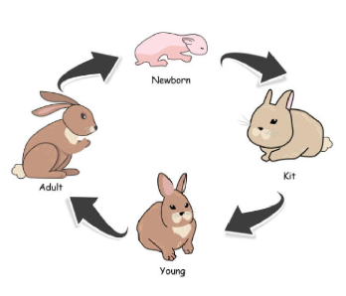 | First, second, third, fourth, fifth  next, then, after, when, until

Description
Describe a wild rabbits features and habitat.  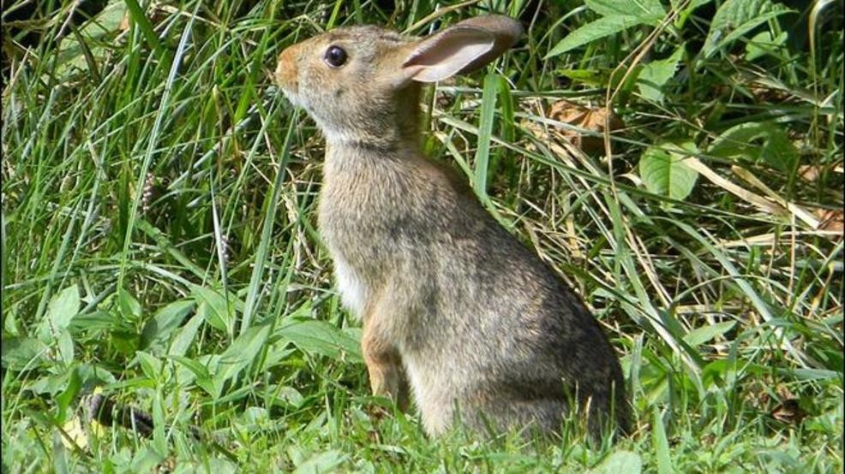 | it has ____, they can_____,  they are____ it is ____  their eyes/leaves/branches are _____

Cause and effect
why do mammals drink milk?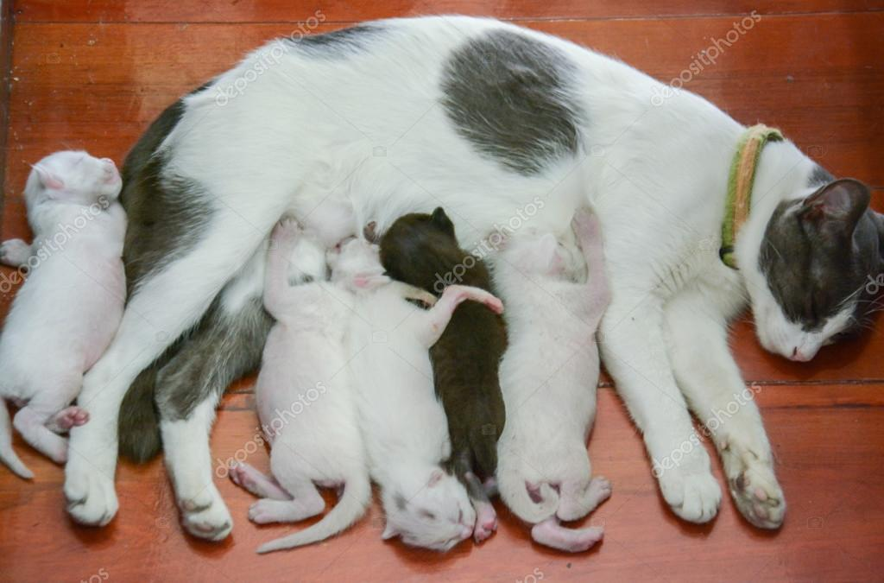 | Because, causes, makes, if, when

compare and contrast
How are rabbits similar and different to Hares?  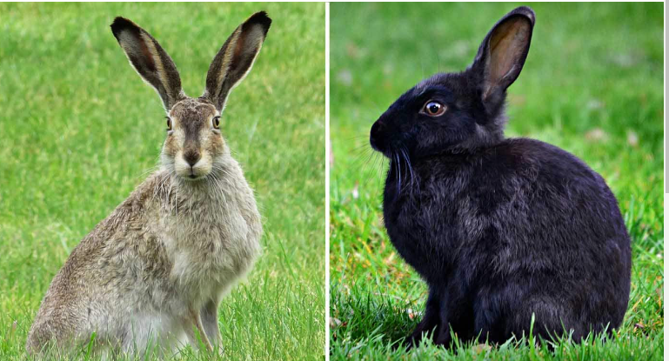 | Both, all, same, different, similar, like, unlike, also.

